**Lecture 271**

**How Does Sending Emails Work?**

Refer notes

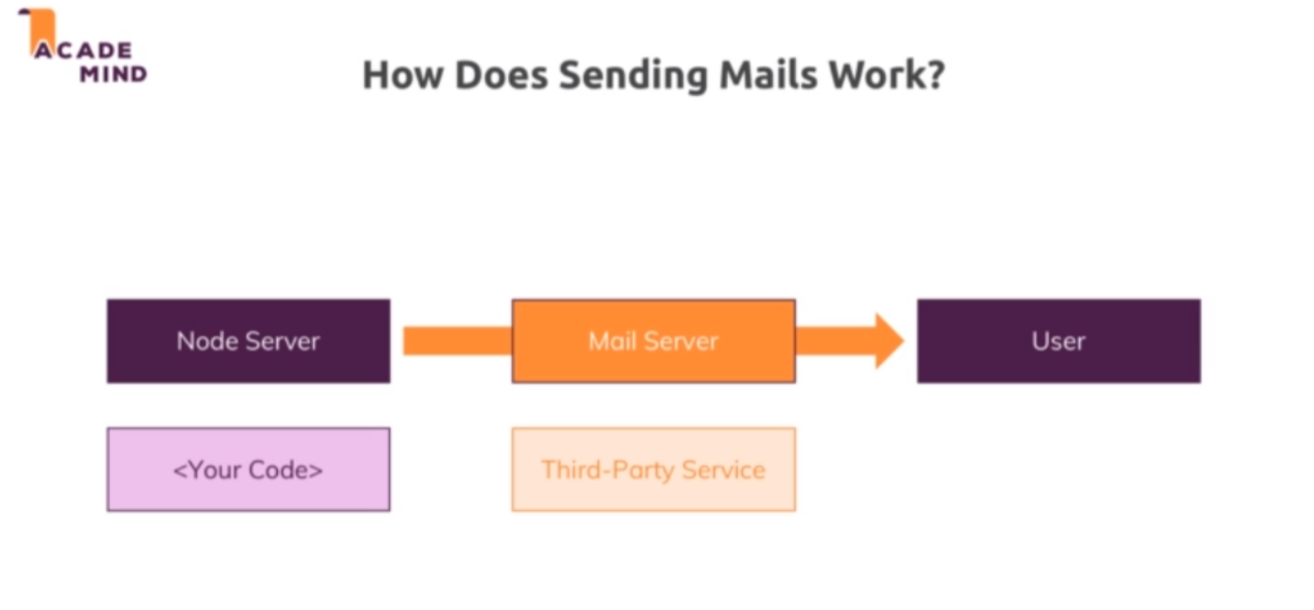

**Lecture 272**

**Using SendGrid**

* Create account in sendgrid
* Npm install –save nodemailer nodemailer-sendgrid-transport
* <https://nodemailer.com/about/>
* <https://sendgrid.com/docs/>

**Lecture 273**

**Using nodemailer to send an email**

* Refer code - sending email
* Create a sender identity in sendgrid site , which serves as the from address while sending emails.
* Create an API key in sendgrid site and use it in controllers/auth.js to initialise the transporter.
* Controllers/auth.js 🡪 postSignup method

**Lecture 274**

**Potential limitation for large scale apps**

Refer notes